**Group 9 Individual Project Report**

**Project Overview**

The goal of this project is to develop a robust face recognition model using a dataset of photos taken during classes. The focus is on creating a model that can accurately identify and distinguish between students in various classroom settings, lighting, backgrounds, etc. We used both track 1 and track 2 methods to implement our face recognition process/model. We were able to achieve high accuracies for track 1 models when compared to performances of models from previous quarters and were also successfully able to implement track 2 which has given our highest accuracy for the provided data set.

**Task Distribution**

We had a total of three members in our group, namely myself Karumanchi Samuel, Archana Vellanki and Chirag Radhakrishna. During weeks 1 and 2 our plan was to find the best way to pre process the data and for weeks 3 and 4 we had planned to train our models and adjust the hyper parameters to get the best output. We planned two ways to approach the task at hand, first way was that all of us work on one model together and try to get the best outcome and the second way was to develop a model each and use ensemble learning approach to get best accuracy. At the end we came up with a final plan of Archana working on track 1 implementation, Chirag working on preprocessing and augmentation of the data set and I worked on implementing track 2 approach. I would say in percentage it comes to about 33.3% of work done by each of us.

**Personal Contribution**

My personal contribution to the project was the entirety of track 2 implementation. I will briefly describe how I went about researching and trying out different things before finally being able to get the final accuracy. Initially I tried the Deepface technique by importing libraries such as face_recognition and installing dlib, etc. I was facing a lot of errors in this method mainly with the shape of the images that were being extracted and that all were of different sizes. So, I tried another approach which also used the face_recognition library but this time it extracted the face features as coordinates and trained the model with these features. But the reference I was using needed me to have images in the json format file and there were few other issues again related to sizes of the images even after resizing them. Finally, the method I used in the end was Multi-Task Convolutional Neural Network (MTCNN) and FaceNet to preprocess the data and then passed it through SVM rbf kernel to get the high validation accuracy of 99.34%. What MTCNN basically does is the below snap shot. It extracts the particular features from an image:

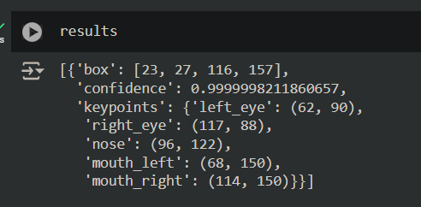

What facenet does is the below figure, it takes the features above, embeds them and stores/compares with features that match closely. Which finally gives us our output.

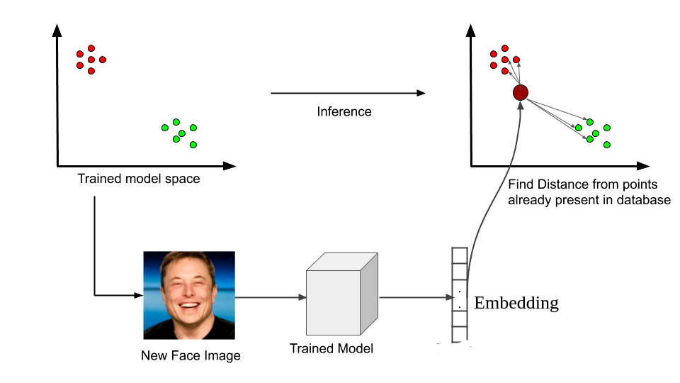

If the project was just about getting track 1 and track 2 implementations, I feel I have done 50% of the work solely and even achieving the high accuracy. But then again there is more than just getting this implementation done, my group members had also done some important tasks which are described in the next section.

**Teammate Contributions:**

I will start with Archana Vellanki; she had implemented the entirety of track 1 implementation with some assistance from Chirag on the data augmentation part. She used this interesting method to extract features called the histogram of gradients (HOG) to get features as histograms. More details are covered in her report I assume. She had worked on this track and had tried running on different models like SVM, random forest and ensemble learning of the two models. We were able to get a high validation accuracy of 94% for track 1 by ensemble learning thanks to her work. Finally, Chirag Radhakrishna; he was the one who took the initiative to help us with the data preprocessing and augmentation. In weeks 1 and 2 he ran the raw data through different models and learned which parameters had to be changed for the augmentation. He implemented different augments like tilting, resizing, etc. We used this augmented data for both track 1 and track 2 implementations. Chirag also prepared the based PowerPoint presentation, confusion matrices and assisted Archana with track 1 implementation. While the contribution may seem insignificant, his augmented data made our accuracies go from 50% to what it stands now for track 1 and from 92% to what it is now for track 2. Thankful for his efforts as well to be there to help where ever it was needed. Overall, I would again confirm that the percentage of work done everyone was equal which is 33.3% each.

**Reflection and Learnings**

The dataset provided had diverse images. There were multiple images with features like varying lighting, student positions, blur and movements. The data augmentation technique proved invaluable in enhancing model robustness. Applying transformations such as rotation, scaling, and cropping helped the model give better accuracy to unseen data. Fine-tuning hyperparameters like learning rate, batch size, and dropout rates was essential to achieve optimal performance. What we learnt was that if we have a diverse data set, we can develop a robust model which would be more consistent to unseen data. I personally enjoyed learning the advanced machine learning techniques like MTCNN and FaceNet. This was my first time working with these libraries and I am so glad that it was a success. I did work on a similar project (face mask detection) a while ago in my undergrad which involved deep learning techniques but back then the concepts weren’t as clear. I now am confident in implementing face recognition both with and without deep learning. The project lays the groundwork for further enhancements, such as integrating the model into a larger attendance system or extending its application to other educational contexts. I even had referred resources which taught how to create an attendance system with the face recognition model which was fun to learn about. I would like to thank our professor for imparting us with the knowledge of machine learning this past quarter, it was a great experience.